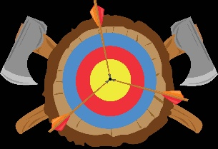

Royal Greenwich district scout

target shooting club

The Twang and Bang is back with exciting training sessions for adults eager to master crossbow, airgun, and archery skills! Whether you're a complete beginner or looking to sharpen your aim, these hands-on courses are designed to help you learn each discipline independently and confidently.

Each course runs over two action-packed days, kicking off at 10 AM and wrapping up around 6 PM, giving you plenty of time to dive deep into the techniques and enjoy the experience. Multiple dates are available, so you can pick the perfect time to join the fun and start hitting your target!

**Why Choose Twang and Bang?**

* Expert instructors with years of experience
* Small groups for personalised coaching
* Safe, supportive, and fun environment
* All equipment provided — just bring your enthusiasm!

**Course Details:**

* **Disciplines:** Crossbow, Airgun, Archery
* **Duration:** 2 days per course
* **Times:** 10:00 AM – 6:00 PM
* **Dates:** Multiple dates available
* airgun 27th/28th September, Archery 25th/26th October, Crossbow 29th/30th November
* **Location:** The Hub Briset Road.

**What You’ll Learn:**

* Proper stance and handling
* Accurate aiming and shooting techniques
* Safety rules and best practices
* Maintenance and care of equipment
* Tips for improving your skills independently

**Whether you’re starting fresh or want to sharpen your skills, our courses offer a unique chance to become confident and capable in each discipline!**

**Ready to take aim?**

Visit us at:  
[www.twangandbang.co.uk](https://twangandbang.co.uk)

Or book directly here:

* Crossbow and airgun Course: <https://twangandbang.co.uk/?page_id=499>
* Archery Courses: <https://twangandbang.co.uk/?page_id=513>

**Contact Us:**  
Email: Greenwichtwangandbang@gmail.com  
Phone: 07738259271

**Twang and Bang – Your target, your skills, your kids, your adventure!**