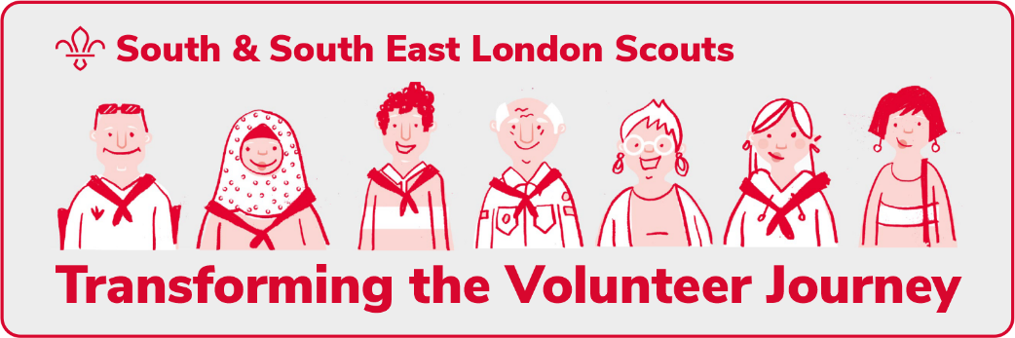
Cleaning and updating
the data on Compass
Readiness statement |  | Complete
Every adult member of our group (including Occasional Helpers) has a unique personal email address, and it has been added to their current Compass record.
Compass is fully up to date for all steps in the current joining process for all adults in our Group

- The current role for all adults in our Group are correct and up to date.
- Our current Occasional Helpers are accurately recorded on Compass.
- Out of date roles have been closed.
- Occasional Helper that are no longer helping out or are no longer needed have been closed.
The personal details for all adults in our Group with a role on Compass, including Occasional Helpers, are up to date on Compass. This includes managing merging any duplicate records for volunteers, where applicable
The organisation records for each section in our group (Squirrels, Beavers, Cubs, Scouts) have been updated on Compass in readiness for the migration
Readiness statement |  | Complete
Working with the District Local Training Manager and Training Advisers (or the new District Volunteer Development Team) our group is confident that all validated modules for the adults in our Group have been recorded on Compass.
We are confident that, wherever possible, all Getting Started modules have been validated and recorded on Compass for all members of our group that are required to complete it.
Readiness statement |  |  | Complete

Our Group has:
- have agreed their new teams structure, including any sub- teams or the group leadership team (if required)
- appointed Team Leaders for these each of our sections
- started to work towards implementing the team description for each team

We have had a conversation with all of our section assistants, and they are aware of the benefits of becoming a team member and the mandatory Growing Roots and First response learning they will need to complete.
We have had a discussion will all adults in our Group whose current role does not automatically migrate to the new system about their future role and team.
Readiness statement |  |  | Complete
Our Group Trustee Board has recognised on their risk register the risks relating to the roll out of the changes. And they have identified mitigations to manage those risks.
I am confident (following input our Group Chair), that our Group Trustee Board is using the new Trustee Board purpose statement to guide its work
- We (the Group Chair and Group Lead Volunteer), are confident that our Group Executive Committee has renamed as Trustee Board (including on its governance documents, agendas and minutes)
- We can answer "yes" to the 2024 census question "Has your Group formally adopted (at an AGM) a constitution for your Group?"
We are aware of the Trustee Board membership changes that will apply from our first AGM after migration (from our 2024 AGM)
Readiness statement |  |  | Complete
The changes to local processes have been communicated in our group

All adults in our Group are aware of the County support process(es) and how to use them locally.

We know the plan to ensure that roles are updated in the new digital system shortly after migration, including any part we need to play in that update.
Readiness statement |  |  | Complete
We have had a discussion with all our adults who have a 'member role' (so not Occasional Helpers), on Compass about their future role title and team
The new processes for permit applications are known in all of our sections and they are aware about how the new processes will operate.
All our sections are aware of the new authorisations for nights away events.
The new processes for Good Service Awards are known to all volunteers in our Group.
I understand the new processes to access dashboards and reporting from the new systems.
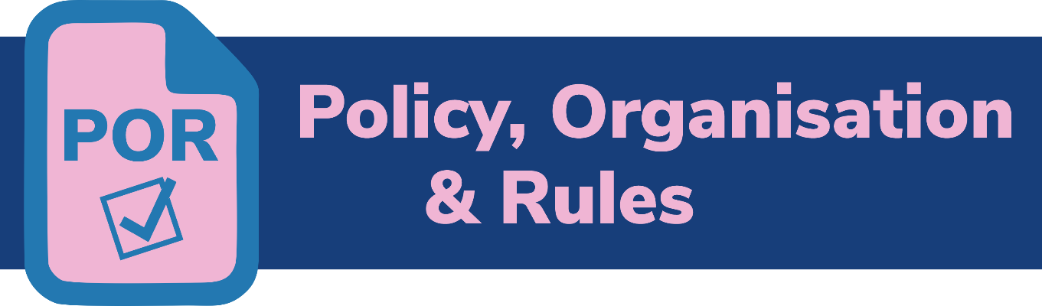
Readiness statement |  |  | Complete

Key volunteers in our Group are aware of the new "January 2024" edition of POR, (which will be available by the end of November 2023), which applies from the date we can access the new digital system (1st May 2024).
Readiness statement |  |  | Complete
We understand the new welcome conversation process and are aware of the steps we need to take to welcome new adults in our group
We have decided who will be part of our welcome conversations with new volunteers and they have completed the welcome conversations elearning ready to receive the accreditation when we move to the new membership system

Readiness statement | Complete
As the Group’s Lead Volunteer, I believe I am sufficiently prepared to lead these changes

