S.W.O.T. Analysis
SWOT stands for strengths, weaknesses, opportunities, and threats. A SWOT. analysis is a great tool that you can use to audit your leadership and governance teams and help to focus on key priorities. This will allow you to build on your section’s/group’s strengths, address your teams’ weaknesses and protect against internal and external vulnerabilities and pressures.

Simple rules for a successful SWOT
- Be realistic about the strengths and weaknesses of your section’s/group’s leadership teams
- SWOT analysis should distinguish between where your leadership teams are today, and where you want them to be in the future
- SWOT should always be specific, avoid grey areas
- Keep your SWOT short and simple. Avoid complexity and over analysis -SWOT is subjective.

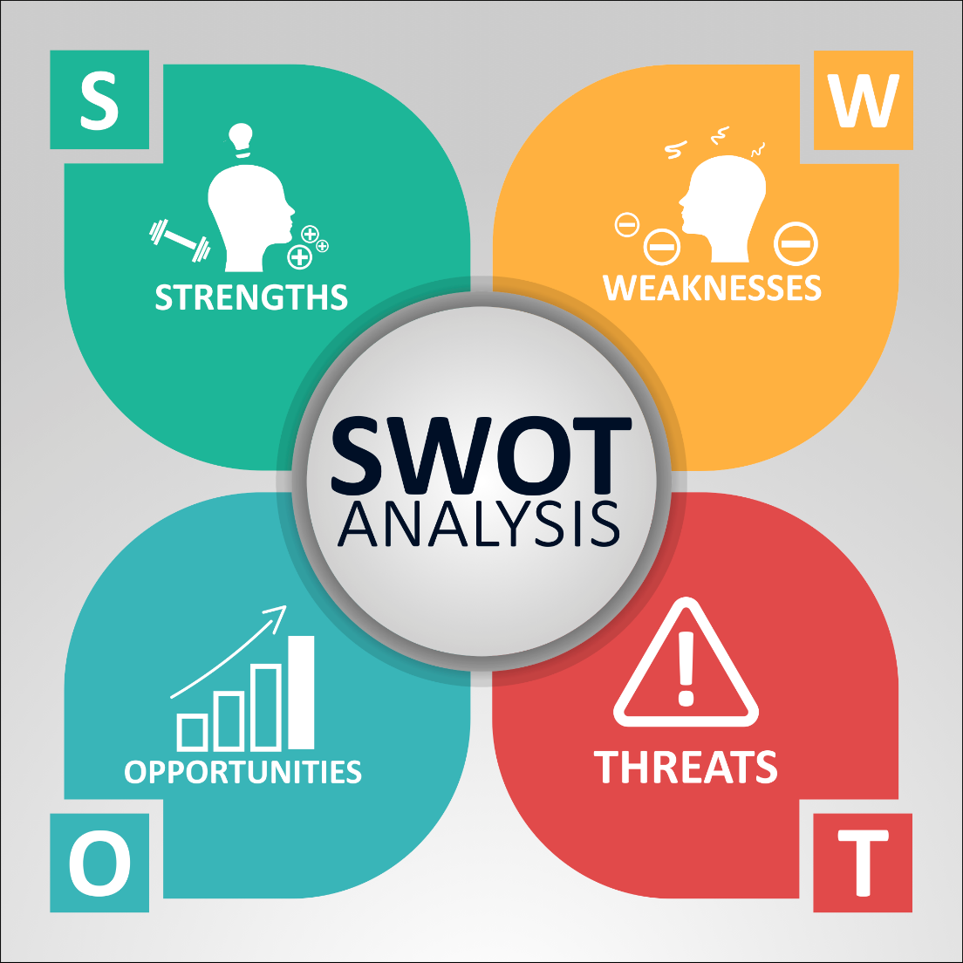

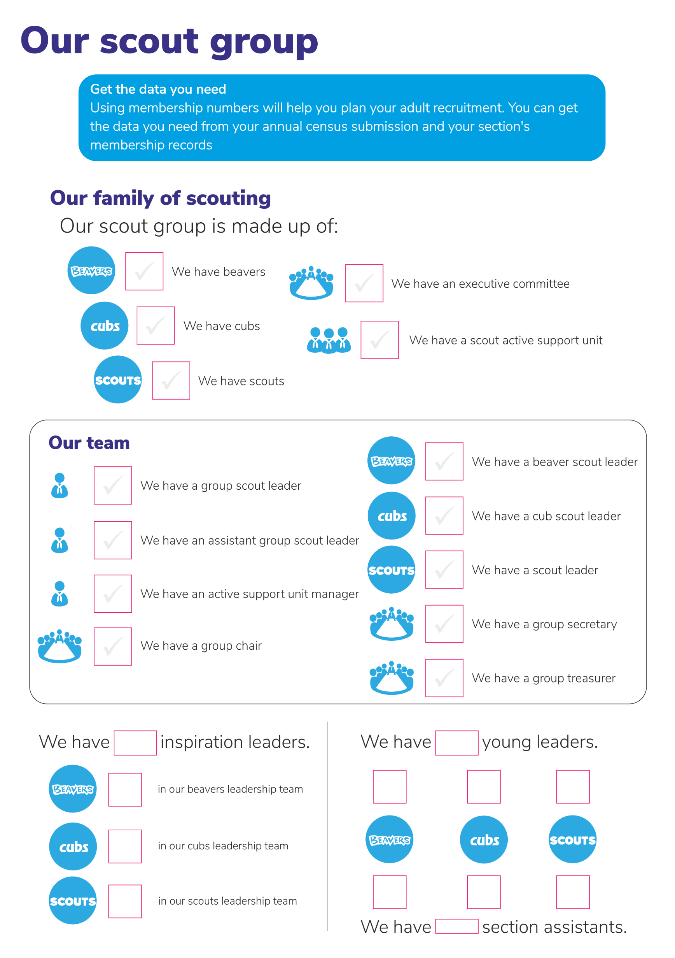
Identify our beaver scout leadership team’s challenges
and celebrate our successes!

STRENGTHS
WEAKNESSES
THREATS
OPPORTUNITIES

Our beaver colony operational priorities
– what we need help with

The tasks that we need help with to run a
well-managed beaver colony

1
2
3
4
5
6
7
8
9
10
11
12

How these can be managed / distributed

 | Task | Currently done by / Could be done by
e.g. | Updating badge records | a parent
1
2
3
4
5
6
7
8
9
10

Identify our cub scout leadership team’s challenges
and celebrate our successes!

STRENGTHS
WEAKNESSES
THREATS
OPPORTUNITIES

Our cub pack operational priorities
– what we need help with

The tasks that we need help with to run a
well-managed cub pack

1
2
3
4
5
6
7
8
9
10
11
12

How these can be managed / distributed

 | Task | Currently done by / Could be done by
e.g. | Updating badge records | a parent
1
2
3
4
5
6
7
8
9
10

Identify our scout leadership team’s challenges
and celebrate our successes!

STRENGTHS
WEAKNESSES
THREATS
OPPORTUNITIES

Our scout troop operational priorities
– what we need help with

The tasks that we need help with to run a
well-managed scout troop

1
2
3
4
5
6
7
8
9
10
11
12

How these can be managed / distributed

 | Task | Currently done by / Could be done by
e.g. | Updating badge records | a parent
1
2
3
4
5
6
7
8
9
10

Identify our executive committee’s challenges
and celebrate our successes!

STRENGTHS
WEAKNESSES
THREATS
OPPORTUNITIES

Our executive committee operational priorities
– what we need help with

The tasks that we need help with to run a
proactive group executive committee

1
2
3
4
5
6
7
8
9
10
11
12

How these can be managed / distributed

 | Task | Currently done by / Could be done by
e.g. | Take notes a exec. meeting | Mildred
1
2
3
4
5
6
7
8
9
10

Identify our scout groups overall team challenges
and celebrate our successes!

STRENGTHS
WEAKNESSES
THREATS
OPPORTUNITIES

Our group operational priorities
– what we need help with

The tasks that we need help with to run a
well-managed scout group

1
2
3
4
5
6
7
8
9
10
11
12

How these can be managed / distributed

 | Task | Currently done by / Could be done by
e.g. | DBSs for new volunteers | George
1
2
3
4
5
6
7
8
9
10

Summary - our weekly leadership needs (each section)

Have | Have
Need | Need
Have | Have
Need | Need

What are our recruitment priorities?
Look at your list of weaknesses, opportunities and threats of each of your SWOT analyses and the list of tasks you need help with and prioritise the things you need to find help with first.

A simple way to do this is to categorise your priorities according to how important they are, and how urgent. This will help you to decide what actions you must take first.

NOT URGENT
but IMPORTANT
URGENT
and IMPORTANT
URGENT but
NOT IMPORTANT
NOT URGENT and
NOT IMPORTANT

How can your Development Service
help with adult recruitment?

They can…

…provide generic and tailored recruitment leaflets and resources
…loan you pop-up banners and displays
…facilitate meetings, workshops and discussions
…support you at recruitment events
…attend recruitment events you can’t make
…help promote adult volunteering opportunities you have identified
…help drive adult recruitment using their existing channels
…help drive adult recruitment using the methods you have decided
…provide advice and inspiration

